Education is not the amount of information that is put into your brain and runs riot there, undigested, all your life. We must have life-building, man-making, character making assimilation of ideas. If you have assimilated five ideas and made them your life and character, you have more education than any man what has got by heart a whole library.”

Swami Vivekananda- Future of India (Complete Works of Swami Vivekananda, Vol 3, p.302)

Executive Secretaries– Strategic Inflexion Points to Top Management’s Vision and Mission
Ram Prasad

Introduction
With the advent of globalization geographies have become history through- increased connectivity, networking and use of virtual space. All these have become possible due to increase in: Automation, Flexibility& Convergence. Speed is the name of the game in this disruptive cycle and Execution is the order of the game without missing out the essence of: Organization Values, Vision and Mission.

With business environment operating on 24/7 real time basis, it requires the role of Executive Secretaries to function with: finesse, flexibility and farsightedness by simultaneously donning the hats of- Operational Excellence

& Strategic Thinking. The rate of convergence and addressing to the multiple stakeholders by modern day EAs is akin to the famous Peter Drucker’s: Knowledge Worker.

Executive Secretary Convergence Paradigm
Top MGT
Multiple Stake Holders Mgt
(Internal+External)

$TRATEGIC
Assisting

Facilitating

Coordinating

OPERATIONS

Internal Stake Holders- Within the Company

Various Functions
Multiple Stake Holders Management

Various Departments

External Stake Holders- Outside the Company

Regulatory Bodies- CLB, FI’s

Trade Associations- CII/FICCI/IMTMA

Role of Executive Assistant in Modern Business
Though it could be euphemistically called as Secretarial function, it revolves and engages with various functions and departments, essaying towards multi-functional perspective.
In order to seamlessly function EA should possess the following skills sets:

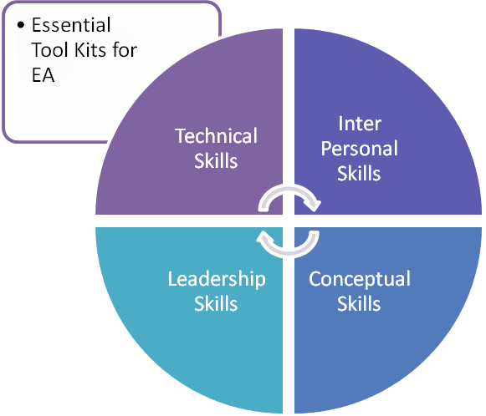
Skills Framework

Leadership Skills | Conceptual Skills | Inter Personal Skills | Technical Skills
- Responsibility  - Deliverance  - Team Management | - Conceptual Clarity  - Understanding newer concepts  - Learning Initiative | - Behavioral Skills  - Soft Skills  - Networking Skills  - Collaborative Skills  - Communication Skills | - IT Skills  - Business Research  - Market Research  - Industry Surveys  - Economic Surveys
Mathematical Equation to Excellence:
Event+ Response = Outcome

EA: Performance Paradigm
The key feature of in any EA’s system is to engage, stimulate and perform with passion. Japanese attach a greater importance to this PQ- Passionate Quotient, as ‘ Ikigai Principle, principles advocated on the lines of being passionate in one’s life and life’s commitment.
(Noted Hollywood actress Audrey Hepburn of 1950’s classic Roman Holiday fame was asked;” Why you do like acting, she quipped, it’s a paid holiday”… )
IKIGAI PRINCIPLE

n
What can be paid for
Profession
What the world needs
Vocation
What you are good at

Mission
IKIGAI PRINCIPLE
What you love
Passion

ACTIVITY TRAP
It becomes imperative for any executive to fell in the trap- Activity Trap Syndrome. Either one is productive or one is meaningfully engaged calls for greater introspection.
It needs to be seen in this matrix perspective of Engagement vs Productivity:

Task Orientation

Important | Urgent
Not Important | Not Urgent
Time Frame

This trap is a common trap, as a solution to this engimatic syndrome, can be found in none other Lord Sri Krsna, who advocates in 3rd Chapter of Gita, Karma Yoga:
“ gyathum icha iti jigyasu”- meaning, a jigayasu or a person willing to learn will exercise-
- What ought to be done against, what one likes to do…, ( Icha Shakthi- Will Power, categorically emphaised. Likes& Dislikes- Raga Dvesha)
- Paraphrasing it further, it is the icha shakthi, will power is the toughest amongst the other 2 shakthis, namely- kriya and jnana shakthi.
- Jnana Shakthi- conceptual skills, is easy, you can read a book, comprehend a theorem or solve an equation.
- Kriya Shakthi- creative skils, is easiest, you can be busy in one way or other, but deemed to be productive!
Attributes to counter Activity Trap

Time Management Technique | Based on time frame, deadlines worked out  Working backwards in reverse clock  Project Management Techniques applied for- Time/Cost over runs.
To Do List- Check List | Check list updation, based on activity completion.
Pomodoro Techniques | Dividing the problems into:  - systems  - sub systems,  - supra systems  as attacking the problem head-on at the first place creates intiative fatigue as the laundary list is more and overwhelming!
Eat your Frog Syndrome | - Never procrastinate, do it now- Nike slogan to be advocated.  - Do it now, enables to counter distractions.
Feel Good Factor ( FGF) | - Execution is not important, it’s the quality of execution which is vital, it befits your personality and enhances your FGF-feel good factor and adds as a great morale booster.
4Ps- Plan- Prioritise- Position- Play | Noted self help author Brian Tracy calls for 4Ps- Plan, Priotise, Position and Play as fundamental factor in executionary skills.
Chunk it Down | ‘ Be the best, Do the best’- is the paradigm which needs to be followed, as many variables are beyond our control…

Managing Relationships
Human relationships are most the complex and easy ones to be nurtured, at the fundamental level it drills down to human beings in implementing various policies and initiatives of management.
Varied theories may work, counter theories may work, it’s the fundamental resolve to: understand, empathise and cultivate relationship which is the essence of managing relationships.
In this paradigm, how are you going to manage your-boss, superiors?
Different boss or managers will be of different mindset and personality traits. Some of the traits to be followed by any sub-ordinates is to practice, internalise and implement these key issues as a part of day-day dealings:
Nature of Managers ( Indicative Lists only) | Attitudes needed
Popular or Sanguine Manager- Calm, serene and composed in disposition. | People oriented skills- Interactive Mode
Tasks Oriented Manager- Tight Deadlines on agenda | Technical oriented skills- Deliverable Mode
Melancholy Manager- Sad disposition, lower energy levels | Uptick with humor and engage with him positively and change the situation and outcomes dramatically. Subtle to good humour can diffuse the situations.  Engage in good conversations, take it to a different trajectory.
Picture Perfect or Phlegmatic Leader- fault finder, cynical oriented boss | Never react, just respond to the tasks.

Self Awareness
Doctrine of Self Awareness is not to be left to be left seers alone, practicing managers need it in abundance, as it answers to their existential crises, especially in modern era ( read it as CoVid 19 era)
Self Awareness | Self Management- Reasons for existence
Inner Peace | Calm, collected and composed dimenour needed to tackle any situation(s) going overboard.
Never Judge | Don’t judge, ask and validate, as each and every situation differs.
Suspend your ego | Suspension of ego- will do a world of good- as what is right is more important than, who is right!  What is right is- conceptual understanding- Yes! apples do fall, be it in: Bangalore, Boston or Brazil.  Who is right is- dispels from behaviorial dysfunctionalities arisen out of closed or cluttered mind.
Listen More | Practice the old adage of- Speech is silver, silence is golden, by listening more.  Listening directly internalises within sub-conscious mind.  Listening is 200%, nature has given two ears, to listen more.
Develop Right Perspectives | Right intent, right outlook, right perceptions ( self explanatory) akin to Buddha’s 8 fold pathways to nirvana, with the first of the attribute is- Right Intent. It’s the right intent creates right content.
Engage Yourself | Engage yourself, be a solution provider, be humourous, have banter and wit under your sleeve, it can open many doors and connects with people.
Comfort of Ease | Create a comfort of ease while dealing with strangers, create- Confidence Building Measures ( CBMs) as it is the first step to rapport building.
Create Trust Factor | Trust, credibility and reliablity factors, as technical skills can be polished upon, not integrity issues. Look to Warren Buffet’s famous quote on integrity:  “ 3 decades old integrity can be wiped in 30 minutes”
LINA Factor | Listen with Interest and Praise- constructively engage with people by listening to their accomplishments and achievements.
LOGO Therapy | Practice Logo Therapy- Find reasons to live. Have MSP part of conscious tool kit- meaning, significance and purpose to your existence, which will make a world a better place to live.

Conclusion

Attending such programs for Executive Assistants will not only enhances and enriches the knowledge perspective but gives you a multi-disciplinary perspective to become a better solution provider.

Ram Prasad
Govindram1919@gmail.com

